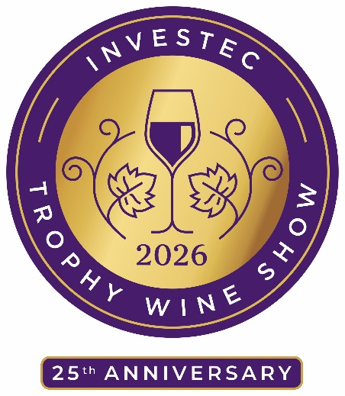
Trophy Winners

Investec Trophy for South Africa’s Champion Winemaker of the Year
Juandré Bruwer of Diemersdal Wine Estate
Harold Eedes Trophy for Best Chenin Blanc
Investec Trophy for Best White Wine Overall
Vinolok Trophy for Best Premium Wine
Cederberg Five Generations Chenin Blanc 2024
Investec Trophy for Best Cabernet Sauvignon
Investec International Judges’ Trophy
Investec Trophy for Best Red Wine Overall
Delaire Graff Estate Cabernet Sauvignon Reserve 2022
Trophy for Best Chardonnay
Cavalli Chardonnay 2025
Investec Trophy for Best Niche Red
Rosa Kruger Trophy for Best Old Vine Wine
Allée Bleue Old Vine Cinsaut 2025
Investec Trophy for Best Shiraz
Investec Trophy for Discovery of the Show – Best Value Gold Medallist
Nederburg The Winemasters Shiraz 2024
Investec Trophy for Best Rhône-Style Red Blend
John Skotnes Trophy for Best Blended Wine
Zwartwater Estate Red Blend 2024
Investec Trophy for Best Semillon
Regna Loca by Rickety Bridge Semillon 2025
Tony Mossop Trophy for Best Cape Port
Delaire Graff Cape Vintage 2023
Investec Trophy for Best Niche White
Diemersdal Grüner Veltliner 2024
Trophy for Best Cap Classique
Graham Beck Méthode Cap Classique Blanc de Blancs 2020
Trophy for Best ‘Other White Blend’
Kloovenburg Eight Feet 2024 (Grenache Blanc, Chenin Blanc, Roussanne, Verdelho)
Riedel Trophy for Best Bordeaux-Style Red Blend
Neil Ellis The Left Bank Cabernet Sauvignon Merlot 2021
Trophy for Best Pinotage
Bellingham The Bernard Series Bush Vine Pinotage 2023
Trophy for Best Sauvignon Blanc Semillon Blend
Boschendal Suzanne 2024
Trophy for Best Sauvignon Blanc
Hermanuspietersfontein Sondagskloof Sauvignon Blanc 2024
Trophy for Best ‘Other Red Blend’
Boschendal Nicolas 2023 (Cabernet Sauvignon, Shiraz, Merlot, Cabernet Franc)
Investec Trophy for Best Pinot Noir
Paul Clüver Estate Pinot Noir 2024
Trophy for Best Organic Wine
Stark-Condé Monk Stone Chenin Blanc 2025
Investec Trophy for Best Pinotage-Based Red Blend / Cape Blend
Boland Cellar Reserve Red 2024

Trophy for Best Museum Class Dessert Wine
Trophy for Best Museum Class Wine Overall
Nederburg The Winemasters Noble Late Harvest 2018

Trophy for Best Museum Class Cape Port
Boplaas Cape Vintage Reserve 2016

Trophy for Best Museum Class Sauvignon Blanc
Diemersdal The Journal Sauvignon Blanc 2021

Trophy for Best Museum Class Niche White
Leeuwenkuil Grenache Blanc 2016

Trophy for Best Museum Class Cap Classique
L’Ormarins Private Cuvée 2017 (Anthonij Rupert)

Trophy for Best Museum Class Pinot Noir
Boschendal Appellation Series Elgin Pinot Noir 2015
Gold Medal Winners
Bellingham The Bernard Series Basket Press Syrah 2024
Cape of Good Hope Altima Sauvignon Blanc 2025 (Anthonij Rupert)
Constantia Uitsig Natura Vista 2024 (Sauvignon Blanc Semillon White Blend)
De Krans Cape Vintage Reserve 2015 (Cape Port, Museum Class)
Delaire Graff Estate Banghoek Chardonnay 2024
Diemersdal Private Collection 2021 (Bordeaux-Style Red Blend)
Diemersdal Syrah 2023
Diemersdal The Journal Pinotage 2023
Glen Carlou Chardonnay 2025
Graham Beck Méthode Cap Classique Cuvee Clive 2019
Hazendal Bottelary Hills Syrah 2025
Hazendal Chenin Blanc 2025
Jordan Timepiece Chenin Blanc 2025
Kleine Zalze Family Reserve Cabernet Sauvignon 2021
KWV Cathedral Cellar Sauvignon Blanc 2024
Laborie Le Traditionnel Cap Classique Blanc de Blancs 2020
Mellish Bakenkop Blanc Fumé 2020 (Wooded Sauvignon Blanc, Boutique Class, Museum Class)
Nederburg Heritage Heroes The Brew Master 2021 (Bordeaux-Style Red Blend)
Perdeberg G.O.A.T Chenin Blanc 2025
Roodekrantz Donkermaan Chenin Blanc 2024
Spier 21 Gables Sauvignon Blanc 2023
Stellenzicht Thunderstone Red 2024 (Blend)
The Fledge & Co Vagabond 2024 (White Blend)
Warwick The White Lady Chardonnay 2024
Zandvliet Estate Shiraz 2024

